RESOURCES

BROCHURES
- Composting Fruit and Vegetable Trimmings
- Compost Bins – Sources and Designs

BOOKS
Backyard Composting, 1992. Harmonious
Technologies, Harmonious Press,
Ojai, CA, 96 pp.

Let It Rot!, 1975. Stu Campbell, Garden
Way Publishing, Pownal, VT, 144 pp.

Rodale Book of Composting, 1992.
G. Gershuny, Saint Martin's Press,
New York, NY, 278 pp.

Worms Eat My Garbage, 1982.
Mary Appelhof, Flower Press,
Kalamazoo, MI, 100 pp.

T

BASIC

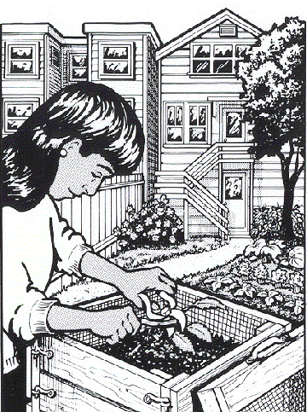COMPOSTING

URN YOUR GARBAGE INTO GOLD! IT'S EAST, IT'S SMART, IT'S RECYCLING.

WHY COMPOST?

Composting is nature's way of recycling. It is a satisfying way to turn your fruit, vegetable and yard trimmings into a dark, crumbly, sweet-smelling soil conditioner.

COMPOSTING:
- Saves you money by lowering garbage bills and replacing store-bought soil conditioners.
- Helps garden and house plants by improving the fertility and health of your soil.
- Saves water by helping the soil hold moisture and reducing water runoff.
- Benefits the environment by recycling valuable organic resources and extending the life of our landfill.

THE 4 "R'S" OF THE YARD
REDUCE the amount of yard trimmings you make by planting slow-growing, drought-tolerant plants.
REUSE yard trimmings by grasscycling (mowing more often, and leaving the clippings on the lawn) and by mulching fallen leaves and chipped prunings (spread them 6" deep on paths and around trees and shrubs).
RECYCLE remaining yard trimmings by composting. This brochure shows you how.
RESTORE the environment with thriving gardens. It all starts at home!

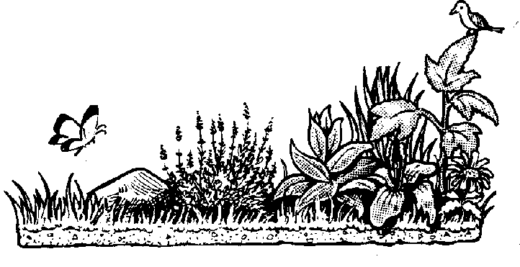COMPOST WORKS FOR YOU

Not only does composting help the environment, but it can help your garden, yard, and house plants too! When compost looks like soil and smells sweet and earthy, it is ready to use. Here are some of the most common ways to use compost:
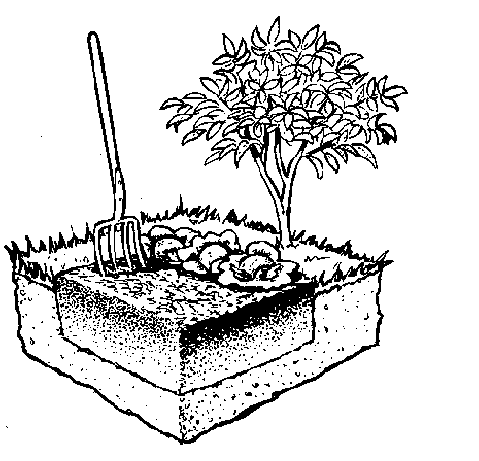

IN THE GARDEN
Before planting, mix a 4" to 8" layer of compost into newly reclaimed or poor soils. Mix a 1/2" to 3" layer of compost into annual garden beds at least once a year. Compost will add nutrients and beneficial microbes, hold water, and improve plant growth.

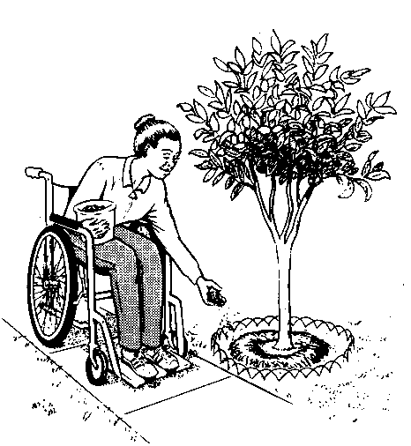AROUND THE YARD
Spread a 1" to 6" layer of coarse compost on soil as a mulch, or spread a 1/2" layer of sifted, weed-seed-free compost on turfgrass as a top dressing. These can be done any time of year to improve soil fertility and reduce watering needs.

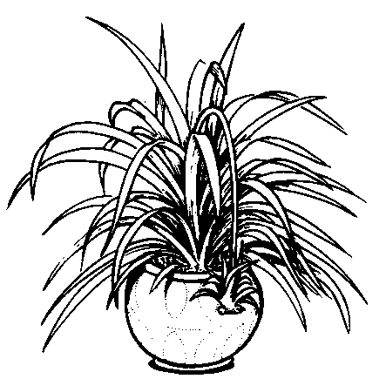
ON HOUSE PLANTS
Sprinkle a thin layer of compost over house-plant soil to provide nutrients. You can also make a great potting soil by mixing one part compost with two parts sand and/or soil.

DON'T HAVE A GARDEN?
You can still make compost and use it on a house plant, give it to a friend, sprinkle it around a street tree, or use it in a community garden.

CHOOSE A SYSTEM

SYSTEMS FOR FOOD AND YARD TRIMMINGS

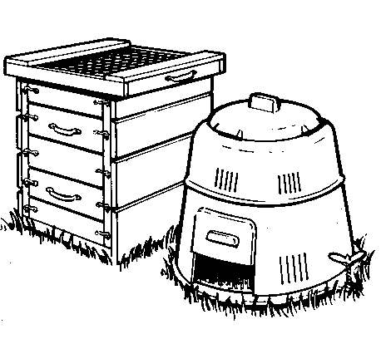RODENT-RESISTANT BINS
- For fruit, vegetable and yard trimmings (using "Mixed" compost recipe)
- For yard trimmings alone (using "No-Fuss" recipe)
- Bins require a lid, floor and no holes bigger than 1/4"

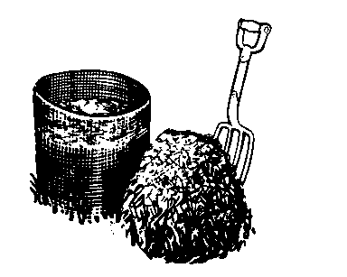OPEN PILES & SIMPLE BINS
- For yard trimmings ONLY
- Requires "Active" composting (chopping and weekly turning to keep animals out)
- Usually inexpensive or free

SYSTEMS FOR JUST FOOD TRIMMINGS
For more information about the following, see the Composting Fruit & Vegetable Trimmings brochure.
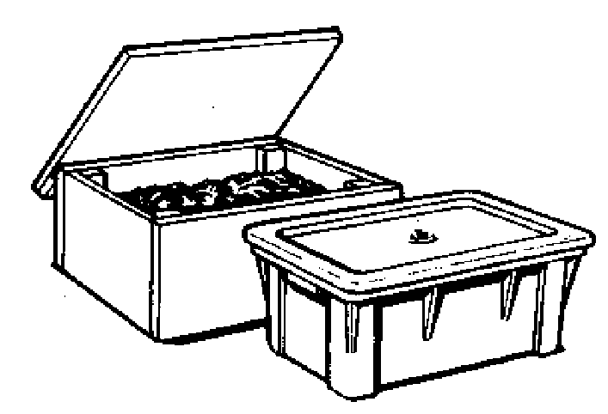
Worm Bins
- Most fun! Takes some time and effort
- For indoors or outdoors
- Produces excellent fertilizer
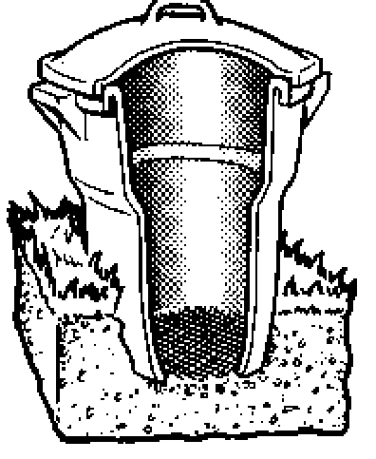
Closed-Air Systems
- Low maintenance
- Prone to odor and insect problems

Underground Composting
- Requires digging a hole each time you add new materials
- No harvesting necessary

REMEMBER...Whenever you compost fruit and vegetable trimmings, the Health Department requires a rodent-resistant system. Use a container with a lid, a floor, and no holes bigger than 1/4 inch, or bury food scraps at least one foot under he soil surface. For more information about bins, see the Compost Bins – Sources and Designs brochure.

FOLLOW THE BASICS
Thanks to friendly bugs and worms, composting is as easy as "1-2-3"—no matter which recipe you use!
1 CHOP materials if you want them to break down more quickly.
2 MIX "browns" (dry, woody materials) with "greens" (moist, green materials).
3 MAINTAIN air and water balance by keeping compost as moist as a wrung-out sponge.
Browns, Greens, Air and Water are the "big four" that will keep every compost pile happy.

DO COMPOST: |  | DON'T COMPOST:
 | - Most sawdusts | - Meat, bones or fish
 | - Chopped, woody prunings | - Dairy products or grease
 | - Pine needles | - Grains, beans or breads
 | - Fallen leaves | - Dog, cat or bird feces
 | - Tea bags | - Sawdust from plywood/treated wood
 | - Citrus rinds | - Diseased plants (in cold piles)
 | - Coffee grounds and filters | - Fruit and vegetable trimmings (in open piles/simple bins)
 | - Lawn clippings & young weeds
 | - Fruit & vegetable trimmings
 | - Herbivore manures

HOT COMPOST HAPPENS when you follow the basic "1-2-3" carefully, and the pile is about a cubic yard (3'x3'x3'). Heat can accelerate composting and kill weed seeds and plant diseases, but is not necessary. Cold, slow piles are just as good. If your pile is large enough, moist, and well chopped, but not heating up, you can turn it and mix in some greens like grass clippings or an organic nitrogen fertilizer. For faster hot composting and better weed-seed kill, turn or mix your hot pile about once a week.

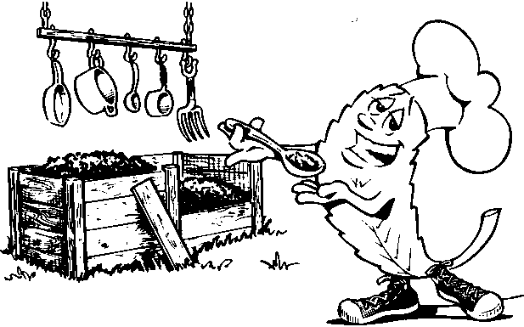RECIPES FOR RODENT-RESISTANT BINS

troubleshooting
SYMPTOMS | PROBLEMS | SOLUTIONS
Pile not composting | Too dry | Add water until slightly damp & turn (mix)
 | Too much brown matter | Add fresh green matter or organic nitrogen fertilizer & turn
Pile smells rotten/attracts flies | Too wet/too many food scraps or lawn clippings | Turn & add browns (dry, woody materials) or dry soil
 | Food scraps exposed | Bury & mix food scraps into pile
 | Non-compostables | Remove meat, dairy, grease, etc., & turn
Rodents in pile | Food scraps in open bin/holes larger than ¼-inch/non-compostables | Use traps or baits, rodent-proof bin, remove meat, greate, etc., & turn

